



发明日志
Invention Log

3-12年级组
Grade 3-12

全球发明大会中国区组织委员会



明大会中国区
NV NT N
NVENT N
H NA

2023-2024我的作品信息
My invention information for the academic year 2023-2024
请在这一页填写你的发明作品信息。
可以快速让别人知道你做了一项怎样的发明。
Please f1ll in your invention information on this page.
It can quickly let others know what kind of invention you have created.

发明作品信息
About Your Invention
团队名称  Team Name | Justin Guo | 作品名称  Invention Name | Bionic Ankle
队员姓名  Inventor Name(s) | Justin Guo
所在城市  City | Shanghai | 学校名称  School | Shanghai High School International Division
就读年级  Grade(s) | 10 | 辅导老师  Teacher
作品主要功能  Key Functions of Your Invention | Provide a bionic leg for disabled, able to do pronation, supination, dorsiflexion, and planar flexion (2 dimensional movements).
作品原型照片  Pictures of Your Invention | 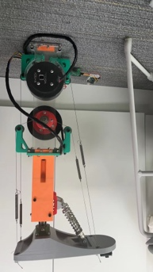



明大会中国区
NV NT N
NVENT N
H NA

2023-2024我的竞赛主题
The theme of my competition for the academic year 2023-2024
ICC 结合 “十四五”规划和 2035 年远景目标纲要以及联合国可持续发展目标（SDGs） 设置了 15 个竞赛主题和驱动性问题。
看到这些现实的社会问题（或者你关注到其他任何主题方向的问题）有什么想法和灵感呢？ 一起用科创的力量建设美好的未来吧。
ICC has established 15 competition themes and driving questions through 14th Five-Year Plan (2021-2025) for National Economic and Social Development and the Long-Range Objectives Through the Year 2035.
What ideas and inspirations do you have when you see these real social issues (or any other thematic directions you are concerned about)?
Let's work together to build a better future with the power of innovation.

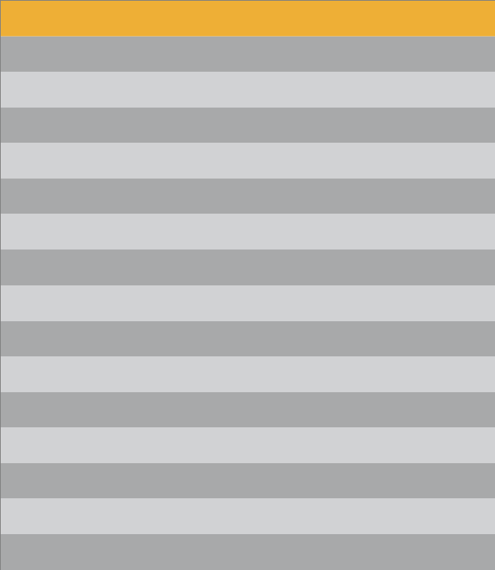  主题 | 驱动性问题
Theme | Driving Question
无障碍世界 | 我们如何创造一个无障碍的世界？
Accessibility for All | How can we create a barrier-free world?
包容与关爱 | 我们如何让生活更具包容性？
Including Everyone | How can we make life more inclusive?
可持续社区 | 我们如何让我们生活的社区更可持续？
Sustainable Communities | How can we make our communities more sustainable?
守护蓝色海洋 | 我们如何保护我们的海洋？
A Blue Revolution | How can we protect our oceans?
未来学校 | 我们如何让学校变得更好？
Future Schools | How can we create a better school?
食品的未来 | 我们如何确保未来没有饥饿？
The Future of Food | How can we feed the future?
零浪费生活 | 我们如何创造一个零浪费的世界？
Nothing Wasted | How can we create a zero-waste world?
老年福祉 | 我们如何让老年人有更好的生活？
Help the Aged | How can we make life better for old people?
水就是一切 | 我们如何确保每个人都有安全、洁净的饮用水？
Water is Everything | How can we ensure everyone has safe, clean water to drink?
与自然为友 | 我们如何在与自然的和谐中创新？
Going Wild | How can we innovate in harmony with nature?
共向清洁未来 | 我们如何让每个人都能利用清洁能源？
Cleaning Up the Future | How can we give everyone access to clean energy?
传承与弘扬中华文明 | 我们如何保护我们的文化？
Preserving the Past | How can we preserve our culture?
保持安全 | 我们如何让世界更安全？
Staying Safe | How can we make our world safer?
健康的未来 | 我们如何构建一个更健康的未来？
A Healthy Future | How can we build a healtheir future?
让乡村生活更美好 | 我们如何建设宜居宜业和美乡村？
Better Village Life | How can we build a livable, prosperous, and beautiful countryside?
我的发明相关主题是： 无障碍世界 Accessibility for All
My invention relates to the following theme



明大会中国区
NV NT N
NVENT N
H NA

2023-2024我的发明日历
My invention calendar for the academic year 2023-2024
● 请随意使用本页，可以圈画、标记出你的发明时间计划。
Feel free to use this page. You can circle, mark, or note down your invention timeline plans.

9月
September

10月
October
日 一 二 三 四 五 六
1 2 3 4 5 6 7
8 9 10 11 12 13 14
15 16 17 18 19 20 21
22 23 24 25 26 27 28
29 30 31

11月
November
日 一 二 三 四 五 六
1 2 3 4
5 6 7 8 9 10 11
12 13 14 15 16 17 18
19 20 21 22 23 24 25
26 27 28 29 30

日

3
10
17
24
31

12月 1月
December January
一 二 三 四 五 六 日 一 二 三 四 五 六
1 2 1 2 1 2 3 4 5 6
4 5 6 7 8 9 7 8 9 10 11 12 13
11 12 13 14 15 16 14 15 16 17 18 19 20
18 19 20 21 22 23 21 22 23 24 25 26 27
25 26 27 28 29 30 28 29 30 31

二
日

6
4
11
18
25
5
12
19
26
13
20
27

2月
February
三
四
1
7
8
15
22
29
14
21
28

五
2
9
16
23

六
3
10
17
24

3月 4月 5月
March April May
日 一 二 三 四 五 六 日 一 二 三 四 五 六 日 一 二 三 四 五 六
1 2 1 2 3 4 5 6
1 2 3 4
5 6 7 8 9 10 11
12 13 14 15 16 17 18
19 20 21 22 23 24 25
26 27 28 29 30 31
3 4 5 6 7 8 9 7 8 9 10 11 12 13
10 11 12 13 14 15 16 14 15 16 17 18 19 20
17 18 19 20 21 22 23 21 22 23 24 25 26 27
24 25 26 27 28 29 30 28 29 30
31

6月 7月 8月
June July August
日 一 二 三 四 五 六 日 一 二 三 四 五 六 日 一 二 三 四 五 六
1 1 2 3 4 5 6 1 2 3
2 3 4 5 6 7 8 7 8 9 10 11 12 13 4 5 6 7 8 9 10
9 10 11 12 13 14 15 14 15 16 17 18 19 20 11 12 13 14 15 16 17

16 17 18 19 20 21 22 | 21 22 23 24 25 26 27 | 18 19 20 21 22 23 24
23 24 25 26 27 28 29 | 28 29 30 31 | 25 26 27 28 29 30 31



If you want to showcase a unique invention story
如果你想展现独特的发明故事
我的发明日志
My invention Log
（使用提示： 如果你想要记载发明故事和过程，可以自由使用本日志页面记录，见证你的 发明过程。例如：在发明过程中做出了什么行动、行动的方式方法、以及行动的结果 … … 这些内容可能包括图纸、计算、描述、测试结果等。如果你想放入视频，可以将视频链接 地址或二维码放在空白页上。这些页面可以自由增加页数。）
(Usage Tip: If you wish to document invention stories and processes, feel free to use this journal
page to record and witness your invention journey. For instance, actions taken during the invention process, methods employed, and the outcomes of these actions……These contents may include
drawings, calculations, descriptions, test results, etc. If you wish to include a video, you can place the video link address or QR code on a blank page. You are free to add pages as needed.)
日期Date 1/29/2024

Today, I first learned how to use electronics, and how to use Arduino. After downloading Arduino, I first started on how to control the basic electronic components. Controlling the electronic components is relatively easy. First, I need to connect the electronic component to my Arduino board using wires and confirm a connection in the virtual layer. Once the connection is created, I can start controlling the electronic component. Using functions digitalWrite and analogWrite, I can then send the directions to the electronic component.
Once I learned how to control the electronic component, I started on a mini project: building a car. I first started on building the hardware of the car, involving two wheels, two motors, battery, switch, frame of the car, Arduino board, and infrared ray receiver and sender. Some were glued on the board. Others are attached to intentional clip left on frame. After some work, the car is done. I immediately started on coding the software. I started on building 5 functions to control the car to go forward, backward, left, right, and stop.
Then, using the infrared ray receiver and sender, I can control the car. Except it that the buttons seem to have a lot of delay, which is not fun.



我的发明日志 如果你想展现独特的发明故事

My invention log

日期Date 1/30

If you want to showcase a unique invention story

Forgetting about the infrared receiver and sender, I turned to an ultrasonic sensor. This ultrasonic sensor supposedly will use ultrasound to detect the distance between itself and a wall. Its function of ultrasonic sensor is supposedly to avoid obstacles. Yet, the process involves unacceptable delays and failing to turn that I do not understand what happened. I tried to fix these bugs, but the best my car can do is to crash into a wall, and turn after 1 second, then crash into another wall. These bugs just exists forever, even after changing the motor (because I think that it is the motor’s problem.
日期Date 1/31

Since I am planning to create a bionic leg, I will need to plan my leg using Solidworks, an application that can create 3D models. AutoCAD is an 2D drawing tool, which can help me master Solidworks faster. Today is just a day which I draw lines, create shapes, and cut the shapes out to form an easy mobile phone holder. Quite an easy day indeed.



我的发明日志 如果你想展现独特的发明故事

My invention log

日期Date 2/1

If you want to showcase a unique invention story

Today is the day which I learned Solidworks, an essential tool for my modeling. Solidworks is like AutoCAD. I just need to choose a plane, draw my 2D design, and add a depth to it. It is simple if you learned AutoCAD before.
After I learned all the basic skills of the project, I finally can start to begin my project, which starts on 3.17.



我的发明日志 如果你想展现独特的发明故事

My invention log

日期Date 3/17

If you want to showcase a unique invention story

To first started to plan my creation of the bionic leg. Using Solidworks, I started to map out my parts of the bionic leg. I first started to map out the drive leg. The drive leg is where the motor of the bionic leg is at. I need to create the motor-axle machine that will move the foot of the ankle. I need to map out the dimensions of the supporting boards, motors, axles, and other parts that make up the drive leg.
For the bionic ankle, I will want the statistics to be as close to a real human ankle.
An average human calf is around 500mm. So, for the drive leg, I estimated it to be a length of 250mm. The drive legs are the place to put two motors, so it cannot be too short in length.
I first need to design two boards that can fix the motors. To make work easy, the two boards are set to be identical. There will be two parts of the board: the motor part, where a motor is attached to this side, and the axle part, where the axle is attached to it. The first board's motor will correspond to the second board's axle. The first board's axle will correspond to the second board's motor.
The motor has a diameter of 89mm. I estimated that I need 10 mm of spacing between the motors for it to not interfere. There also need some space at the top of the board for connection to top boards and bottom boards. After calculation, the motor’s center is set to be 65.5 mm away from the top of the board. To protect the motor, I also designed a circular baffle on the board to cover the motor. This circular baffle has a radius of 47.5mm, which covers the motor’s 89 mm diameter. Additionally, a small hole must be at present for the motor’s external DIP switch, which is used to control the ID of the motor. Moreover, on the other end of the sideboard, there must be a hole for the axle, which is set for 19mm.
The top boards and bottom boards of the drive leg are different. Both boards need to have a support for the guide wheels, an L-shaped structure with a hole to put in the guide wheels.
The top board is used to connect with the upper leg (either another machine or human upper leg). There is no additional structure on the top of the leg. The upper leg is as follows.



我的发明日志 如果你想展现独特的发明故事

My invention log

日期Date 3/24

If you want to showcase a unique invention story

Today, I plan to model out the bottom part of the leg, which consists of the supporting leg and the foot.
The lower part of the leg is at first a cylinder, but I need to attach a connector and spring system to the leg, so I changed the bottom to a rectangular block. I then drew the connector and spring’s dimensions (they are bought parts) and fit them onto the leg.
Then, I copied the dimensions of the universal joint to Solidworks. The universal joint it going to connect the connector leg with the foot. The universal joint is a mechanical component that allows two-dimensional movement, similarly to the ankle’s movement. It contains three parts: upper Yolk, a block, and lower Yolk.
The foot is a rectangle shaped with a semicircle on top of it. There are two structures that are used to attach the tension springs, but now, it is not connected to it.
Overall, after the end of 3.24, the bionic ankle looks like this.
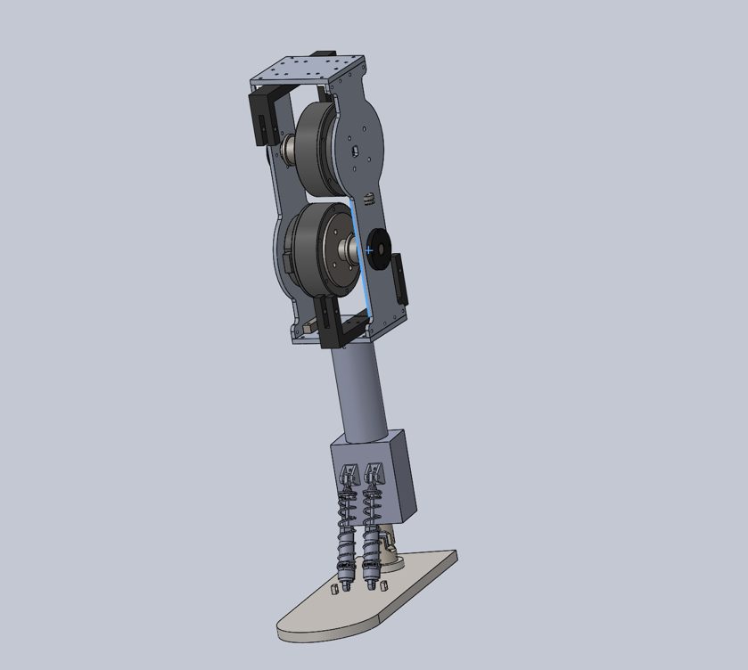

The main framework of the bionic ankle is done, but there are still large rooms for improvements.



我的发明日志 如果你想展现独特的发明故事

My invention log

日期Date 3/31

If you want to showcase a unique invention story

Today, I did the final touches to my first version of the model. For the supporting leg, I added a pair of tension springs that pulls on the springs mentioned above. This will allow a right-left movement for the leg. Also, the leg is redesigned to make it more like a foot, with an increased depth and smooth curves on it. There is also four holes on the corner such that strings can be fixed on here.
The guide wheel supporter has an additional triangular structure so that it’s strength is enough
Then, I added all the screws that connects the whole structure together, and check if there are any adjustments needed to make. For four special screws, an additional cut into the supporting leg is needed to attach the supporting leg and the drive leg together. Also, the connection between the tension spring and spring is calculated such that the screw head will not interfere with the supporting leg.
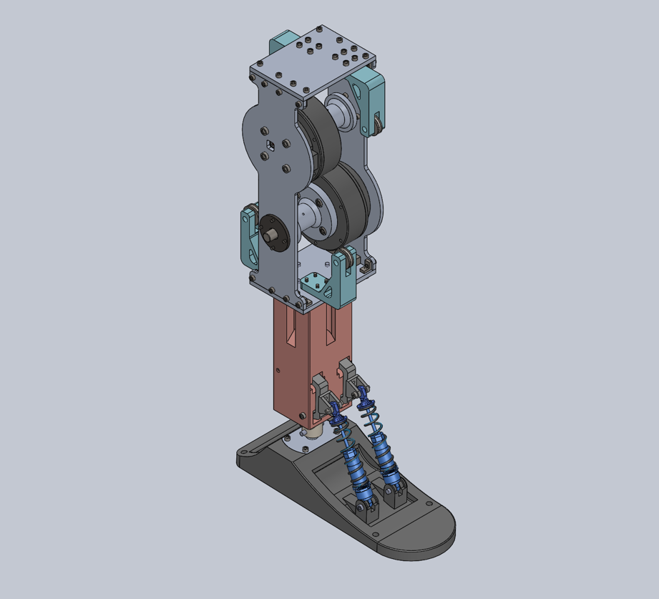
This is the diagram after the adjustments.



我的发明日志 如果你想展现独特的发明故事

My invention log

日期Date 4/5

If you want to showcase a unique invention story

Today, I started to build my first version of the bionic ankle.
I first started the foot. I need to connect the foot with the universal joint. Using screws to work a screw thread into the 3D printed material, I was able to connect them all together. The next part is to connect the universal joint to the supporting leg, which again involves screwing through 3D printed material. After that, I started to build the spring system in the supporting leg. The tension spring is connected to the leg and the connector. The connector part is then connected to the spring, and finally the spring is connected to the foot. Through all of this, the leg can finally stand on its own, and move 2 dimensionally.
After finishing the supporting leg and the foot, I started to work on the drive leg. I first started on connecting the upper and bottom board with the guide wheel supporter and the guide wheel. Then, I started to build the axle and motor system. I put the motor and the axle on one piece of board, and then, put the other one on top of the motor and axle. Then, I used some more connectors to connect the upper and lower board. Finally, the whole drive leg is completed.
To connect the drive leg with the supporting leg, I must screw in the four screws through the tiny trenches. The tiny trenches are so small such that the screwdriver cannot fit into it. Screwing these four screws are tedious work.
With the screwing finally done, the whole bionic leg is finished except for the string system. I need to bind the string on the four corners of the leg.
After the building process, I played with the leg for a bit, and the universal joint connector broke. In therefore need to design a new connector that can withstand more force.
But these are for the next day I work on this project.





我的发明日志 如果你想展现独特的发明故事

My invention log

日期Date 4/19

If you want to showcase a unique invention story

The string binding plan is suspended, as I need to check the functions of the motor. If the strings are bind onto the foot, it is easy to break the whole ankle if some coding goes wrong.
For the motor, I choose three functions: send, stop, and read. Send function can direct the motor to move to a certain angle. Stop function can stop what the motor is doing. Read function can read the angle of the motor.
The read function is the hardest of all, as there are two motors. Each motor will send its data to my computer, ruining each other’s signals. The only way to save this seems to be adding delays to the function, but it is still not fixed completely.
After making sure that the three functions are safe, we fastened up the strings, and tested it. Fastening the strings are not an easy job. I need a lot of strength to pull it and find a good way to attach it the legs. I don’t have a good method to tie a knot or something. It took a lot of time.
After finishing up with the strings, I still managed to break the foot. The place on the foot that relates to the spring broke, which means I need to print the foot. This is the second time when a 3D printed structure broke. This also means that I need to bond the string again.
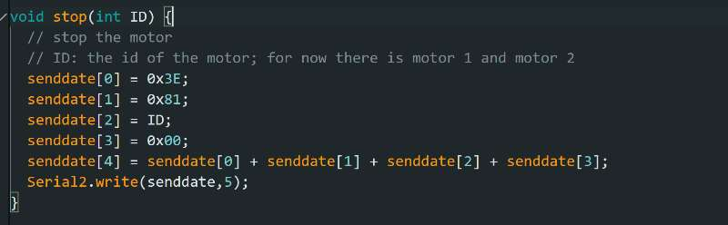
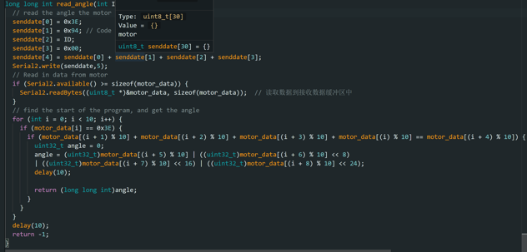
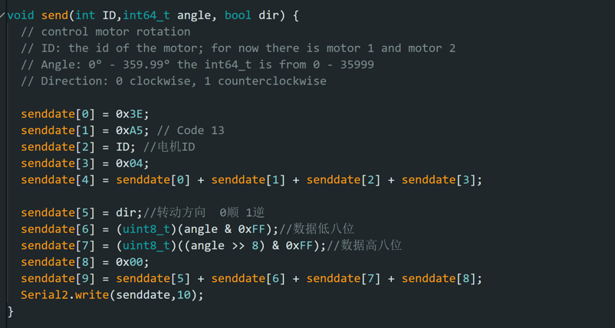
After some more playing and testing with the bionic ankle, I found out some problems that I need to solve in the next version. There must be a way to tighten the strings with the axle, reducing the power loss due to the sliding of the string. The string also needs new ways to fasten onto the ankle, because it is very hard to make it tight. The motor also vibrates a lot, meaning I need to add something to decrease the vibration.



我的发明日志 如果你想展现独特的发明故事

My invention log

日期Date 5/5

If you want to showcase a unique invention story

In this day, I found some better ways to fasten the string, using some string fastening parts, I was able to connect the strings better and faster to the foot. I need to change the holes on the foot of course, but problems in modifying the foot is much easier to deal with.
After the binding of the strings are finished once and for all, I turned to the electronics, which I build up the whole system with Arduino board NANO. I also found new ways to control the foot. There is an increment function in the motor, which will work with moving the foot better than directing the motor to spin to the stated angle.
The increment function is also failing me. The motor just would not move for some reasons I do not understand. I do not even understand how I fixed the problem. I just rewrote the function and it worked for some reason.
Although I was using NANO, but I found out I need a remote-control board to receive data from a planned gyroscope that will be embedded on the bottom of the leg. Using a wire to connect the two will mess up the wiring. So, I changed to esp32, which have a great remote-control function. It also have TX and RX pins on the hardware, therefore not needing virtual basis of TX, RX connection.

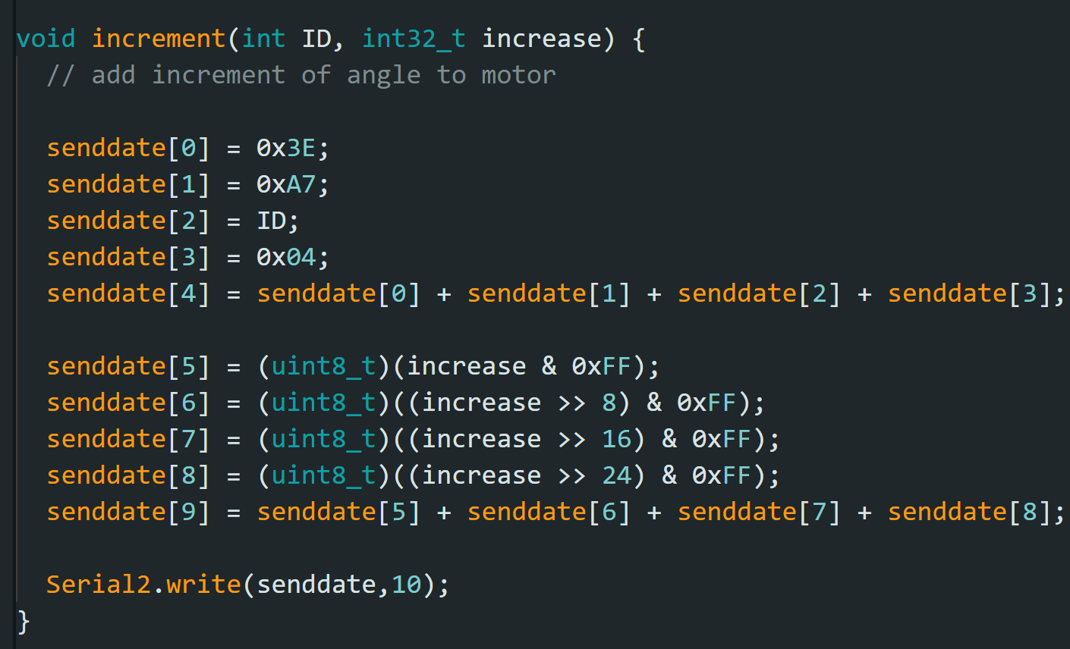



我的发明日志 如果你想展现独特的发明故事

My invention log

日期Date 5/12

If you want to showcase a unique invention story

With the increment function at hand, I started to work on the actual algorithm: PID. Proportional – integral – derivative controller, or PID controller, is a control loop mechanism that calculates the error from the desired values and the process variable and uses proportional, integral, and derivative terms to minimizes the error. The PID controller needs tedious debugging work to get right the variables.
I first tried an easy PID controller using a small motor, but the gyroscope is not stable enough to use PID controller. This mini project was halted sadly.

日期Date 5/19

The morning of 5/19, I kept on adjusting my PID controller, but it constantly broke, and I must keep hold of the ankle to stop it breaking itself.
The afternoon of 5/19 involves learning new application: ADAMS. ADAMS is a strong physics simulator. It can model objects, forces acting on objects, joints between objects, cable systems, and more. ADAMS is a strong tool to help on understanding how the foot moves. I learned how ADAMS can import files from Solidworks, set the joints, add forces and cable systems. Using these functions, I can model my whole bionic ankle into ADAMS. Working on it, I deleted every screw and unnecessary objects to decrease the memory needed to load the model and added joints to make it function like the real one.
The work is still not done yet. There is still a cable system that I have not added onto the ADAMS model, and I need MATLAB to work with it.

\



我的发明日志 如果你想展现独特的发明故事

My invention log

日期Date 5/26

If you want to showcase a unique invention story

MATLAB is a strong mathematics tools that can work with ADAMS. Aside from its powerful ability to draw graphs, it has the possibility to simulate electronics system. Connecting it with ADAMS, MATLAB can control the forces of ADAMS and receive information from it. These means that the whole electronics system can be inputted into it.
I first practiced my MATLAB skills. First, I build a simple seesaw in ADAMS, and try to control a small ball on top of it. I connected it with MATLAB, and build a simple PID controller to control the torque on the seesaw. I then fiddled with the constants in the PID. The ball keeps flying off the seesaw with my numbers. But, at last, I managed to get one that looks fine and stable.
I look to the day where I can simulate the bionic ankle in ADAMS.



注意：灰色部分文字的问题可选填
定义与理解
Identifying and Understanding Note: Issues with text in gray areas are optional to f1ll in
1、你想解决什么问题？ 问题描述地越具体越好。你是怎么想到这个问题的？
What problem are you trying to solve? The more specif1c you are in describing the problem, the better your solution will be. How did you come up with the problem?

As wars started to rage in the world, the rate of disability has gone high. More people need help on missing limbs, notably legs. The most important part of bionic leg is the ankle. Able to produce a good bionic ankle can greatly.

2、你想要达到的结果是什么？ 结果描述地越具体，你的解决方案就会越好。
What is the result you are trying to achieve? The more specif1c you are in describing the result you want, the better your solution will be.

I am trying to make a bionic ankle that can relatively mimic a human ankle, and help disabled people to walk once more.

3、可能的解决方案有哪些？你选择了哪一个？你是怎么决定要使用这种解决方案的？你是 怎么想出解决方案的？ 解决方案描述地越具体越好。
What are some possible solutions? Which one did you choose to pursue? How did you decide which solution to try? The more
specif1c you are in describing the solution you will create, the better your invention will be. How did you come up with the solution?

Some possible solutions are exoskeletons, wheelchair, bionic leg. I choose bionic leg, as I want disabled people to walk once more. Exoskeletons help those that are paralyzed, not those without a foot.



构思与设计 注意：灰色部分文字的问题可选填
Ideating and Designing Note: Issues with text in gray areas are optional to f1ll in
5、绘制你正在考虑制作的发明设计图（草图或工程图） 。
标记所有重要的零件和功能，说明此发明将如何工作。
Draw a model (a sketch or drawing) of the invention you are thinking about building. Label all the important parts and features. Explain how the invention will work.
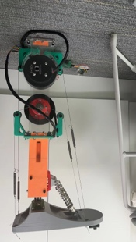
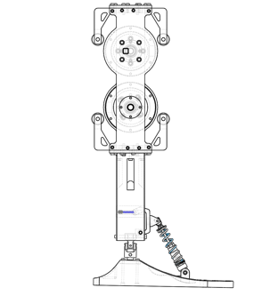
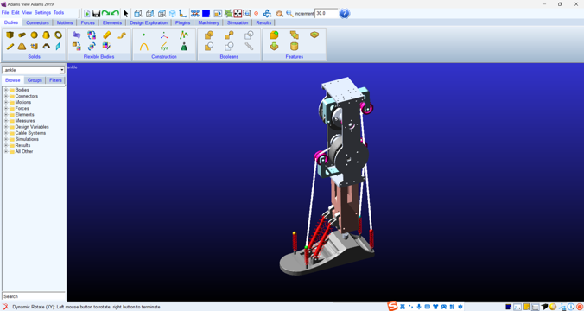
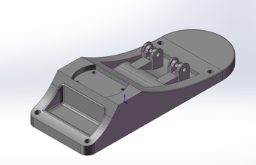
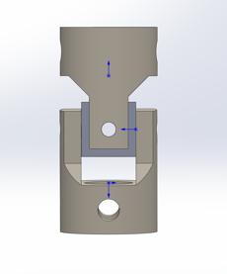
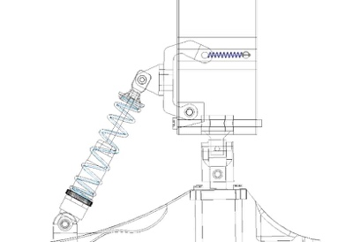
Bionic Ankle
Bionic Ankle as a whole
Motor – String System
Foot
Universal Joint
Spring System
The motors will rotate, turning the strings on the axle, each moving the foot in a diagonal direction. The combination of the two motors can lead to many possible movements of the foot, allowing it to move upward, downward, and sideways. The universal joint grants the mobility of the ankle, while the spring system limits the range of the movement. The spring system also absorbs shock, stabilizing the ankle.

- Spring System: Absorb shock, Stabilize the foot, limit the movement of the ankle
- Universal Joint: Allows movement of the ankle, connects the foot with the leg
- Foot: The foot is the movable part of the bionic ankle
- Motor – string system: This drives the movement of the ankle



构思与设计 注意：灰色部分文字的问题可选填
Ideating and Designing Note: Issues with text in gray areas are optional to f1ll in
6、这个设计可能会遇到什么问题？这种设计是否遵循可持续发展的原则？你和谁讨论过这 个设计（同学、家长、老师等）？他们对你的设计有何评论？
What problems or issues might you encounter with this design? Is this design compatible with the principle of sustainability? Who did you talk to about this design (another student, parent, teacher, etc.)? What were their comments about your design?
This design has encountered problems relating to the read function, the sliding of strings on the axle, and problems relating to tying up the string.

7、如何解决第 6 项中的这些问题？
How can you f1x those problems or address those issues (in No.6)?
- I add delays in the read function to let it work smoothly
- I am planning to add spirals on the axle such that the strings fit into them.
- There are string fastening parts that I can buy.

8、重复步骤 5 至 7 ，直到你认为有一个可行的设计。在有一个好的设计之前，你可能需 要在空白页上进行多次尝试。
Repeat steps 5 to 7 until you have a design that you think will work. You may have to make multiple copies of a blank page until you have a good design.



设计，制作，测试 注意：灰色部分文字的问题可选填
Designing,Building,Testing Note: Issues with text in gray areas are optional to f1ll in

9、此发明需要什么零件、材料和工具，它们要花多少钱？
What parts, materials, and tools will you need to make the invention and how much will they cost?

These are all of the parts and materials that I need to buy online.
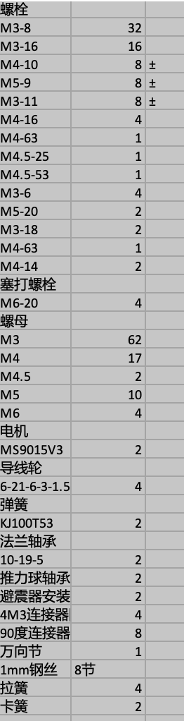

I also need to 3D print, or laser cutting:
Axle, Upper Board, Bottom Board, Side Boards, Supporting leg, Foot, Universal joint connector

10、你将从什么地方获得这些零件和材料？完成此发明需要什么其他的技能或能力？谁可 以帮助你完成此发明？请解决这些问题，并完成此发明。
Where will you get those parts and materials?What additional skills or abilities will you need to make the invention? Who can help you build the invention?Please address these issues and complete this invention.

I will either buy these materials online, 3D printing, and laser cutting. These are the places where AutoCAD and Solidworks will come into action. I also need to cut the metal axle out from a metal pole to complete the work.

13、你给这个发明起了什么名字？为什么起这个名字？
Naming your invention is important. Why choose this name?Where I looked to see if my idea is new:

给发明起名时，你可以从这些角度来考虑：
When naming an invention, you can consider these perspectives:
1)发明解决的问题、实现的功能。
The problem your invention solves and the functions it achieves.
2) 从营销角度考虑，它将如何解决问题和帮助他人。
From a marketing perspective, how it will address issues and help others.
3) 你的发明与已有发明的不同和改进。
The differences and improvements your invention offers compared to existing inventions.
4) 你的目标受众。
Your target audience.
5) 使用一些引人注目的命名技巧，比如押韵、使用数字等。
Use attention-grabbing naming techniques, such as rhyme, using numbers, etc.

This is the function of the project Bionic Ankle. I hope that it is very easy to understand.

14、制作三折展板和路演视频，以更好地展示你的发明。
Create a tri-fold display board and a pitch video to better showcase your invention.

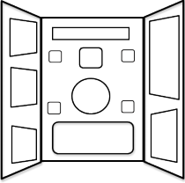


Present your invention story
展示你的发明故事
发明展板
Invention Display Board

设计你的三折展板。右边是发明展板的外观示例图，你
可以根据需要进行调整。请发挥创造力，并用你喜欢的
方式，展示你的发明故事。
Design your tri-fold display board. On the right is an example of the
appearance of the invention display board that you can adjust as needed.
Use your creativity and present your invention story in a way you like.

建议展示的信息：
Recommended information to include:
· 发明的关键功能、如何使用（可展示图纸、表格等）
Key features of the invention and how it is used (can include drawings, tables, etc.)
· 发明是如何完成的
How the invention was completed
· 发明团队简介
Brief introduction of the invention team
· 发明使用的知识及科学原理
Knowledge and scientif1c principles used in the invention
· 用户评价
User reviews
· 队员姓名、项目名称、就读学校、所在城市
Team members' names, project name, school name, city
· 专利状态（未申请、已申请或专利申请中）
Patent status (not applied, applied, or patent pending)
确保使用：
Ensure to use:
· 可清晰阅读的字体
Clear readable font
· 协调的颜色搭配
Coordinated color scheme
· 美观的排版
Attractive layout
· 正确的语法和书写
Correct grammar and writing
· 合适尺寸的展板：展板折叠后的最大宽度不超过 62 厘米
Appropriate size for the display board: The maximum width after folding should not exceed 62 cm



Present your invention story
展示你的发明故事
发明展板
Invention Display Board

请在完成展板制作后，拍下展板的照片，并把照片粘贴在下方。
After completing the display board, please take a photo of the board and paste the photo below.
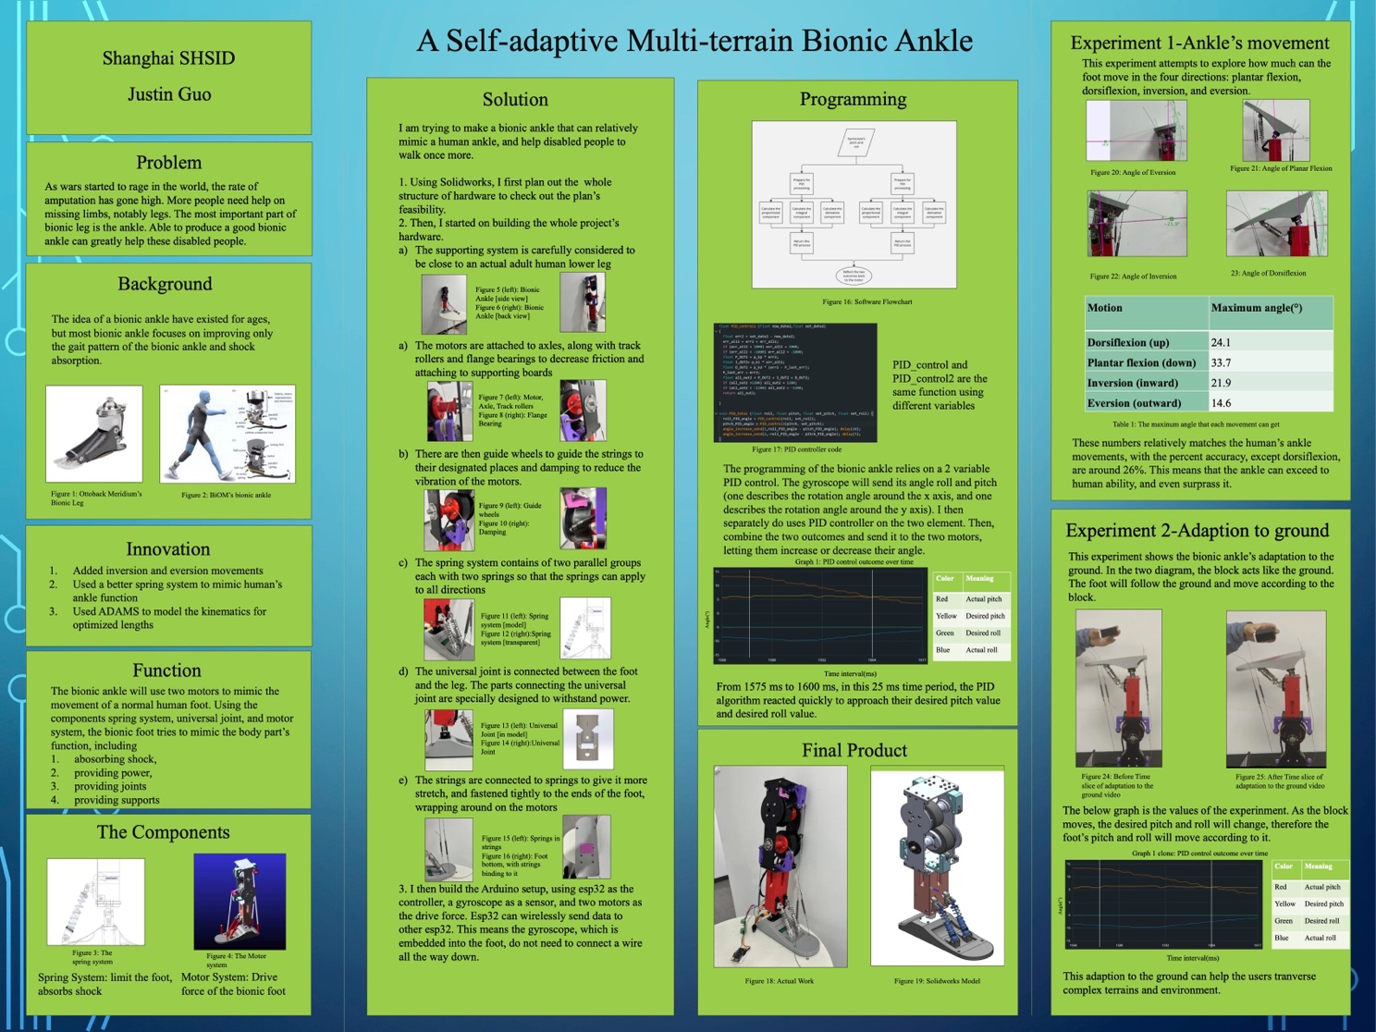



Show your invention story
讲述你的发明故事
路演视频
Pitch Video

你需要录制一段视频，介绍你的发明，并完成上传。
You need to record a video introducing your invention and complete the upload.

建议展示的信息：
Recommended information to include:
· 队员姓名、项目名称、就读学校、所在城市
Team members' names, project name, school name, city
· 发明的关键功能
Key features of the invention
· 发明是如何完成的
How the invention was completed
· 发明使用的知识及科学原理
Knowledge and scientif1c principles used in the invention
· 演示发明原型
Demonstration of the invention prototype
· 用户评价及其他有助于展示发明特点的信息
User reviews and other information helpful in showcasing the invention's characteristics
注意事项：
Notes:
· 视频时长 4 分钟以内，视频大小 500M 以内
Video duration should be within 4 minutes, and the f1le size should be within 500MB
· 连贯拍摄、无剪辑
Continuous shooting without editing
· 全部团队成员出境
All team members present
· 光线适宜、人物居中站立
Suitable lighting, with individuals standing centered
· 使用三折展板和发明原型辅助展示
Use tri-fold display board and invention prototype for assistance in the demonstration
上传平台：
Upload platform:
前往全球发明大会中国区官方网站：www.inventionconvention.cn，按规则上传视频。
Go to the off1cial website of the Invention Convention China: www.inventionconvention.cn, and upload the video according to the rules.



Explore your invention story
探讨你的发明故事
评审圈
Judging Circle

以下是评委可能会在线上和线下比赛现场评审圈中提出的一些问题，你可以写下答案的一些 关键部分，以提前做好准备。
Here are some questions that judges may ask in both online and offline competition evaluation circles. You can write down key parts of your answers to prepare in advance.

· 你的发明解决了什么问题？
What problem does your invention solve?
· 你是如何想到这个问题的？
How did you come up with this problem?
· 这个问题会影响哪些人？
Who does this problem affect?
· 你是如何考虑这个问题的解决方案的？
How did you consider the solution to this problem?
· 你从哪里得到了用于发明的材料？
Where did you get the materials for your invention?
· 谁帮助你完成了发明，他们是如何帮助你的？
Who helped you complete the invention, and how did they assist you?
· 你为这个发明做了哪些改进？
What improvements have you made to this invention?
· 你的发明还有改进的空间吗？
Is there room for improvement in your invention?
· 谁使用过你的发明，他们给出了怎样的评价？
Who has used your invention, and what feedback have they provided?
· 你如何评价自己的发明？
How do you evaluate your invention?



明大会中国区
NV NT N
NVENT N
H NA

2023-2024我的纪念板
My commemorative board for 2023-2024
恭喜你完成了一项发明！
放上一张你在发明过程中最喜欢的照片，再写一句话给自己吧！
Congratulations on completing an invention!
Paste your favorite photo from the invention process in the blank space below, and write a sentence to yourself!

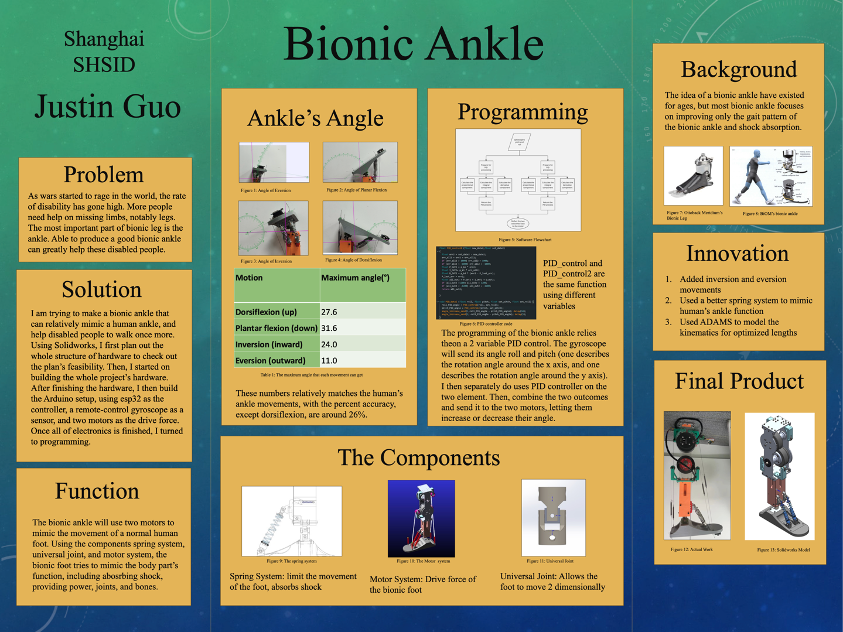

Watching something created is not a sad story.

